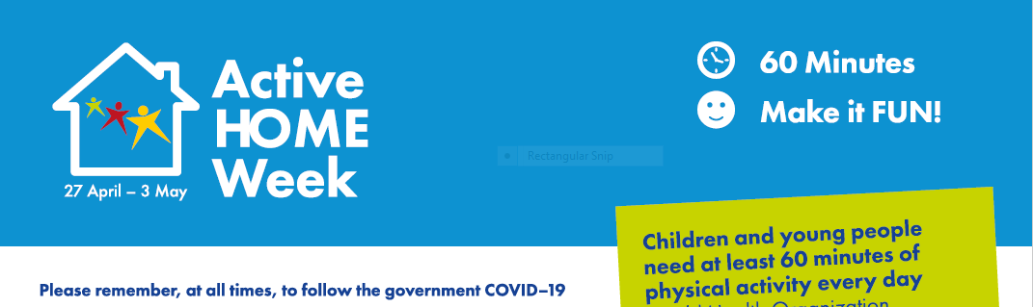

|  |  |  |  |  |  |
| --- | --- | --- | --- | --- | --- |
| **DATE** | **ACTIVITY 1** | **ACTIVITY 2** | **ACTIVITY 3** | **ACTIVITY 4** | **TOTAL TIME** |
| **TUES** |  |  |  |  |  |
| **WEDS** |  |  |  |  |  |
| **THURS** |  |  |  |  |  |
| **FRI** |  |  |  |  |  |
| **SAT** |  |  |  |  |  |
| **SUN** |  |  |  |  |  |

|  |  |  |
| --- | --- | --- |
| NAME -----------------------------  CLASS ------------------------------  TEACHER---------------------------- | I WAS ACTIVE FOR 60 MINUTES EVERY DAY |  |